DIG 4104C Training Manual

**Home Page**

The home page is a hub of information regarding various aspects of the California Police Youth Charities (CPYC), regarding various community programs that they are involved in as well as ways that visitors can contribute to CPYC’s efforts. As a user, you can add icons to the Programs section of the Home page by accessing the corresponding home.php file and inserting code into this Program section. In the Join Us section of the page, your visitors will already be taken to social media page of the corresponding icon that they click on in the Join The Conversation div. Also, the Donate now and Stay Informed sections do not need to be updated since there is already a database that stores the visitor’s email addresses and a payment system in place, respectively.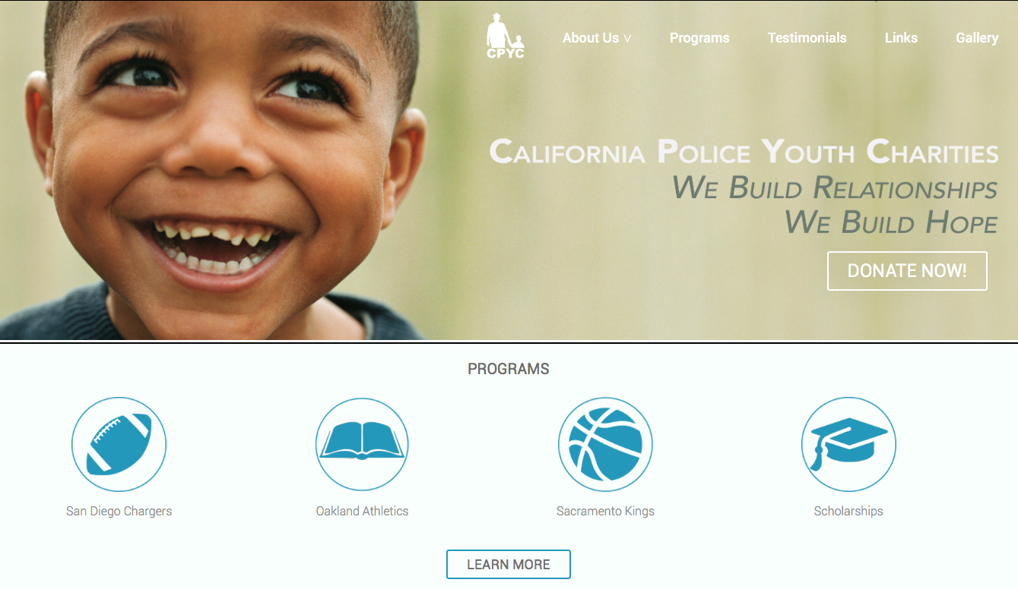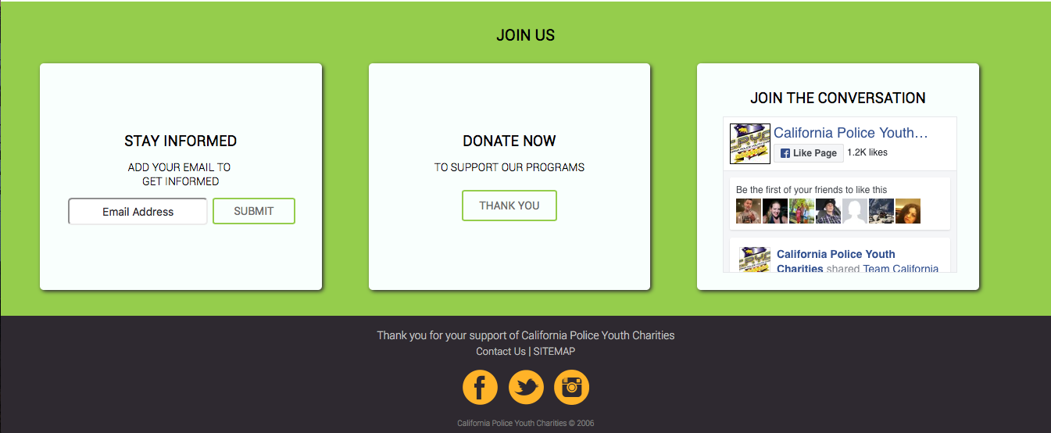

**Gallery**

The gallery contains images depicting scenes from events and children’s programs accomplished by California Police Youth Charities. Here, you can add images to the gallery and remove images from the gallery by inserting <img> tags with all pertinent information into the gallery.html file. Also, you can give your images a text caption. You may also rearrange the order in which images are presented as well as set the duration that each image is displayed for before the next image in the gallery carousel is shown.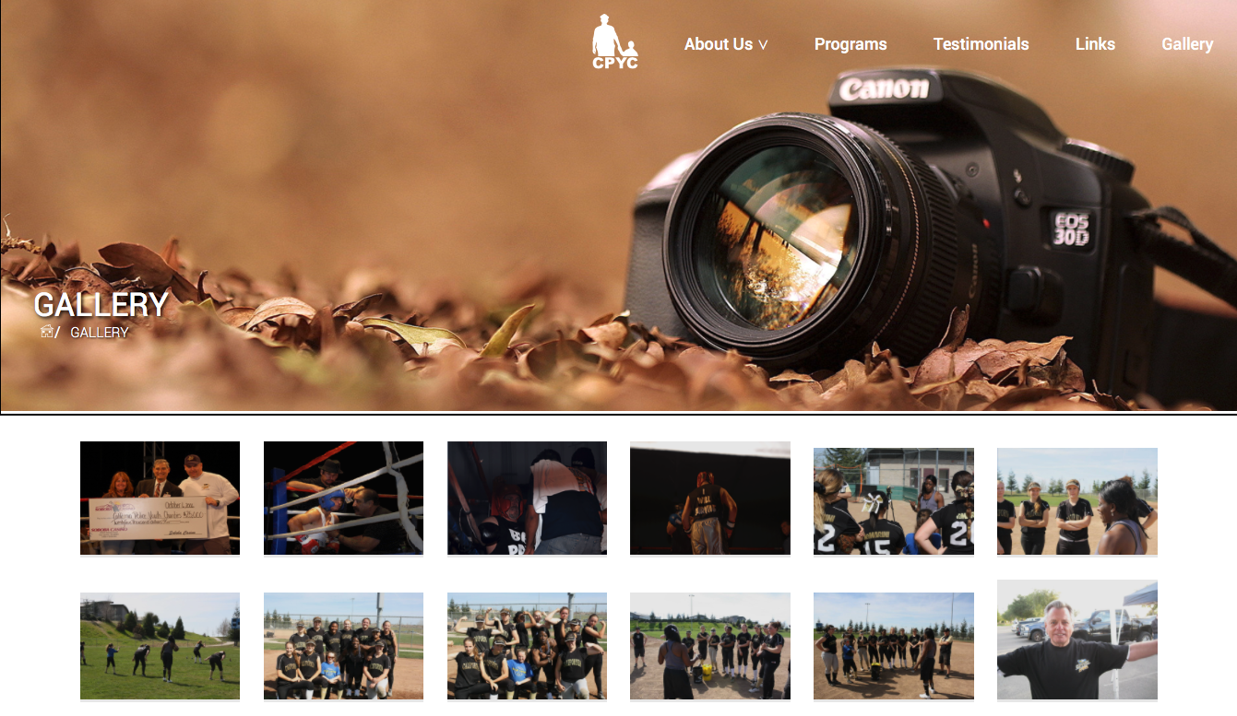

**About Us**

On this About page, you can add information pertaining to the California Police Youth Charities company by inserting paragraph text into the aboutus.html file in order to make changes to CPYC’s mission statement. Also, you may add icons representing CPYC’s scholarships and various partners to the separate div containing the <img> elements.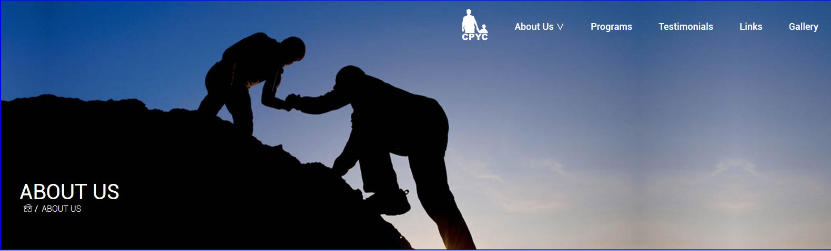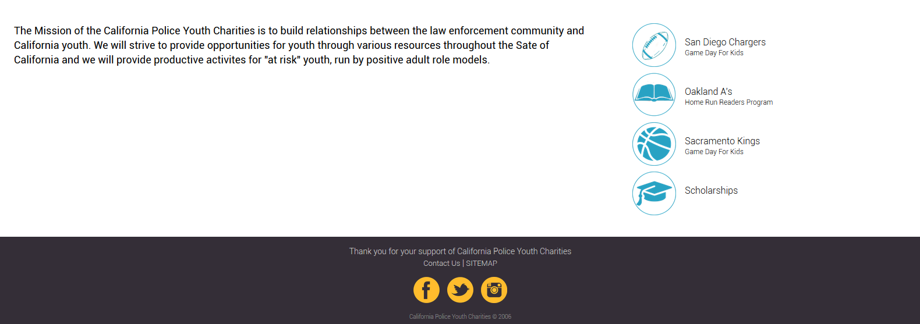

**Programs Page**

The Programs page is dedicated to some of the countless organizations that have helped the CPYC. Nothing that needs to be changed, if need be is a huge deal since it is just information on the organizations that help, however if any more organizations decide to join the group or if an existing organization has either added something new to what they offer or they just pulled out, stuff will need to be added or taken away. To begin with always say what the organization is offering and list a few examples so people can get on board with the programs offered to them and any future programs. To add more content, add a new paragraph div in the columns where everything else is located and match the same div css as before so it looks well organized. These are all the basics needed for advancing the programs page nothing more and nothing less.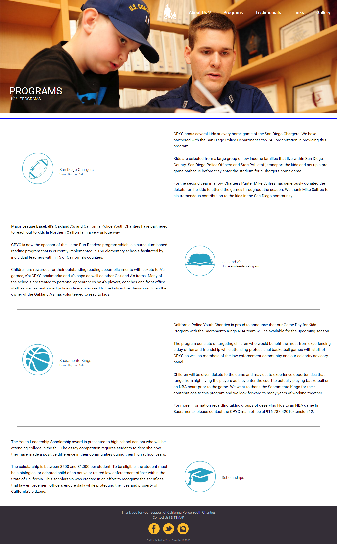

**Links Page**

The Links page is made for similar organizations that the CPYC has worked with in the past and providing a link to their website as well as a picture of their logo. Much like the Programs page all that is needed to do is add any new organization that has worked with the CPYC only this time there is no need to remove anything as all the organizations still promote each other. Each link and image will need to be placed in a column div and need to be organized so the page doesn’t look sloppy. The page should ideally look something like the image below in terms of organization.

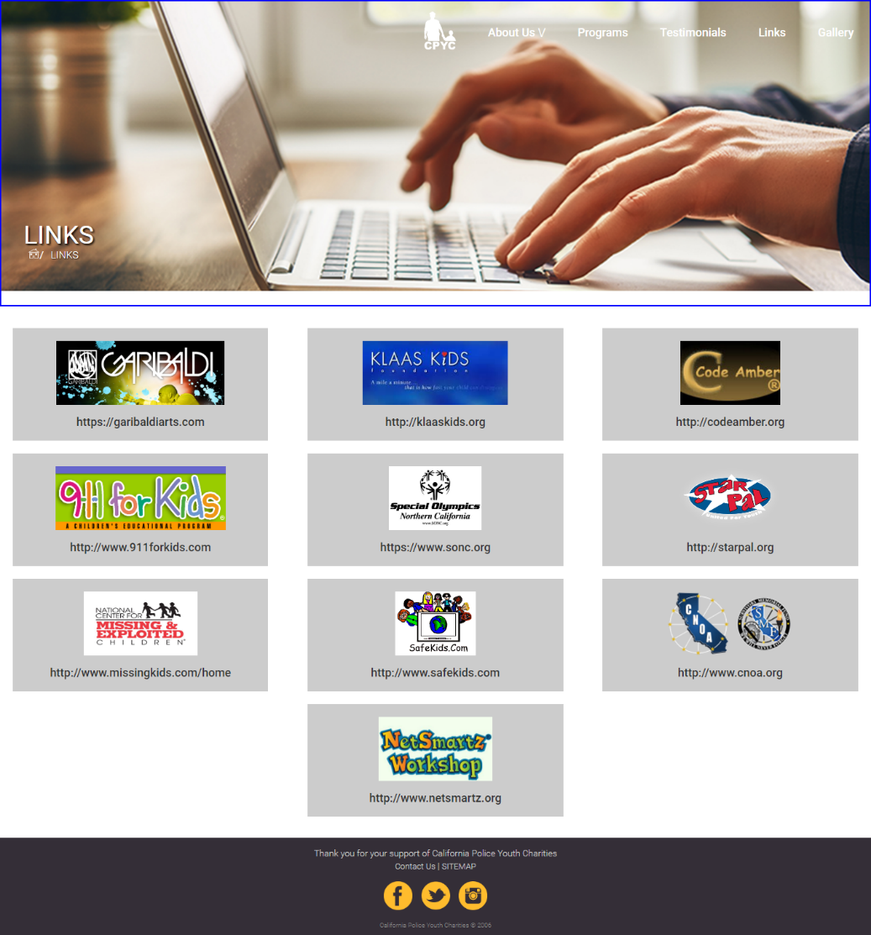

**Testimonials Page**

The Testimonials page is the stories of various people who have had positive experiences with the CPYC. The person usually tells a story about what the CPYC did and how they helped all of the kids that the group has been associated with. Naturally if they help out more people as well as many of the children more Testimonies will need to be documented to show how the CPYC works and how beneficial they are for children. It is always best to include the information of the person making the testimony either to show how important their status is or to show they are just some regular people who benefited from this. Many of the same rules apply adding to the columns and fitting the css of the divs that are on the page. The page should be organized in a fashion similar to the page here.

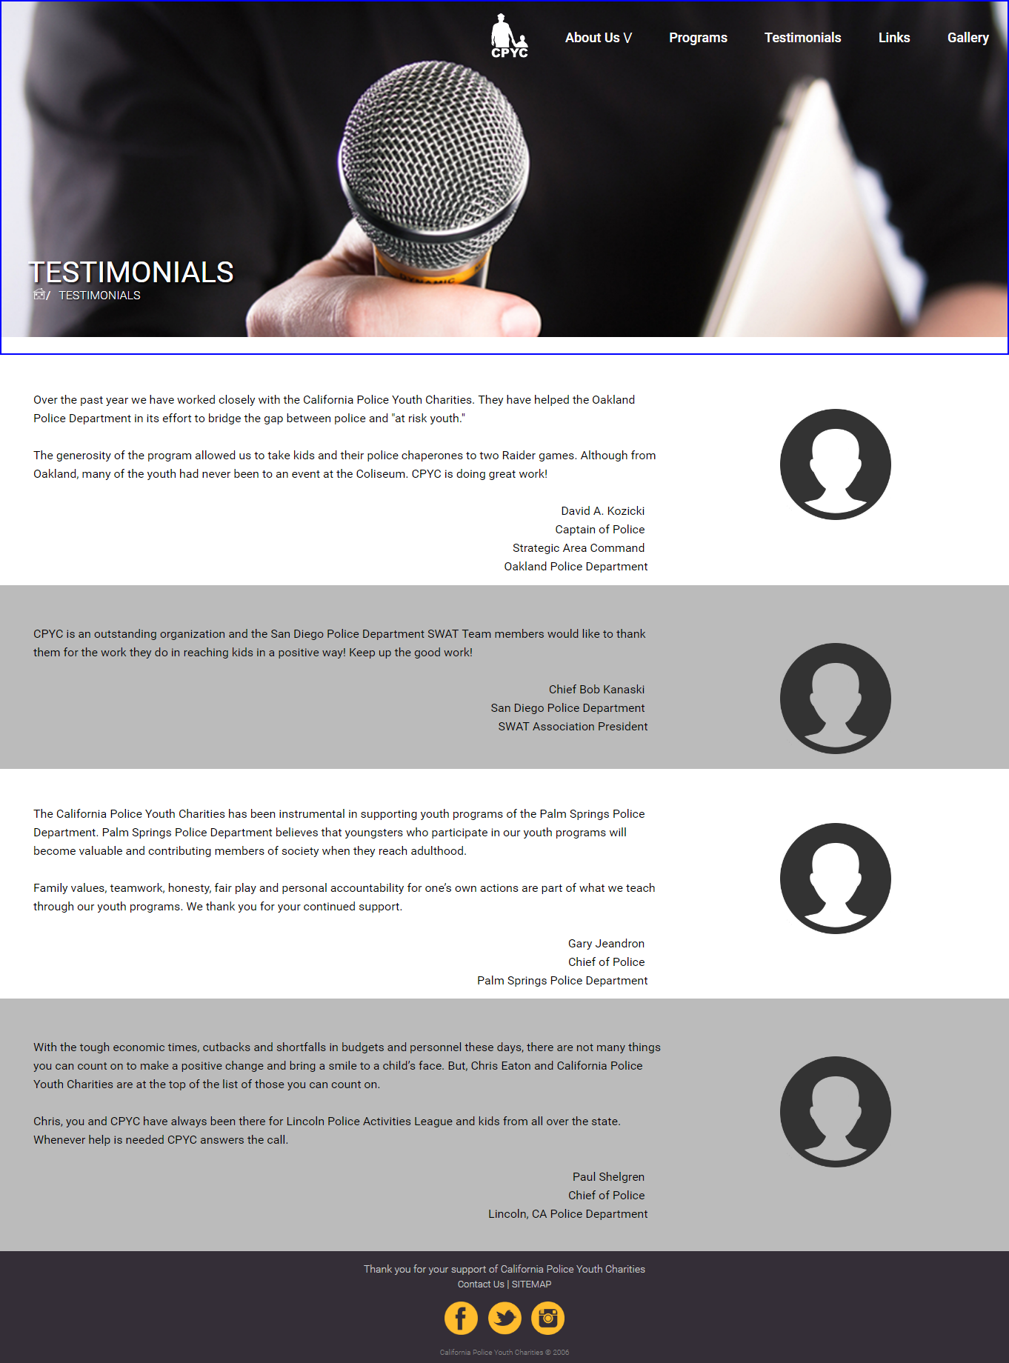

**Board Members Page**

The Board Members page is filled with the people who actually are apart of the groups staff in some way. Each person has a profile picture as well as showing their name and profession as well. This is something that will be needed to be changed or updated depending on whether or not someone leaves or someone new has been added. Keeping it in an organized fashion with divs and columns also helps matching the correct css so it looks seamless when something new has been added. It should be able to match the page that is below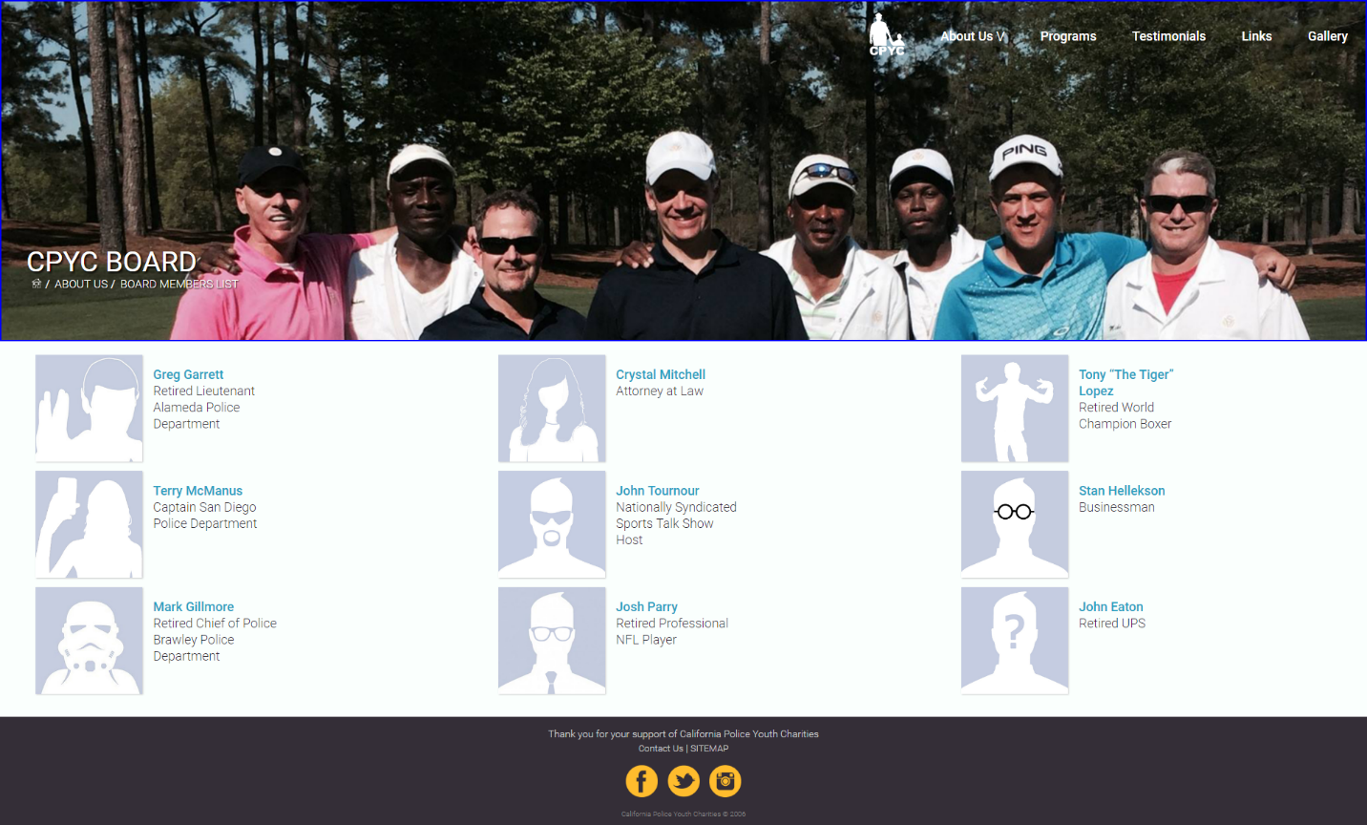

**Sitemap**

The Sitemap page serves as a main hub for all the pages that are on this one page just in case you need a quick easy access to the pages on the site in one place. The Sitemap can be reached at the bottom of the page next to contact us and is simple to maintain as nothing is to be added and all the links are still working. Now if anything needs to be changed all of the buttons are links so if a link stops working or was changed you will have to change the link to the page to the newest link or back the way it was. This is the current page if you need some more instructions.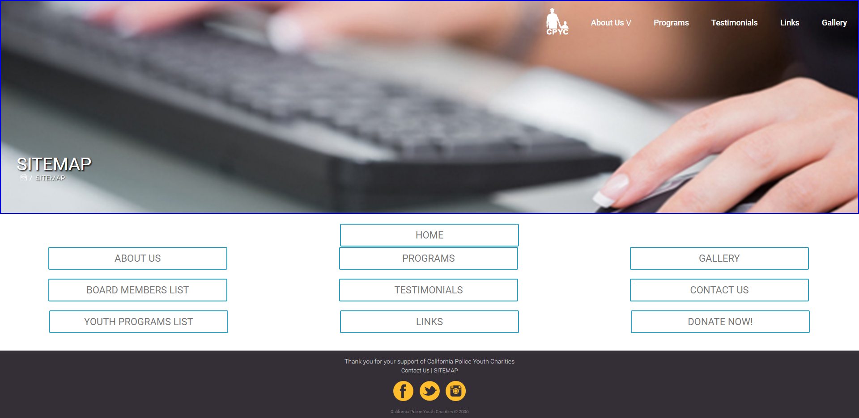

**Contact Us Page**

The Contact Us Page is a way for people to get a hold of the CPYC as well as show the address. There is even a google maps to show where the location is currently and how to get there. The only time this page would need to be changed is if the CPYC changed a location which the easiest part is just changing the contents of the paragraph on the page. The map will also need to be changed to the location that they would be at currently which is also simple. This is what the page currently looks like.

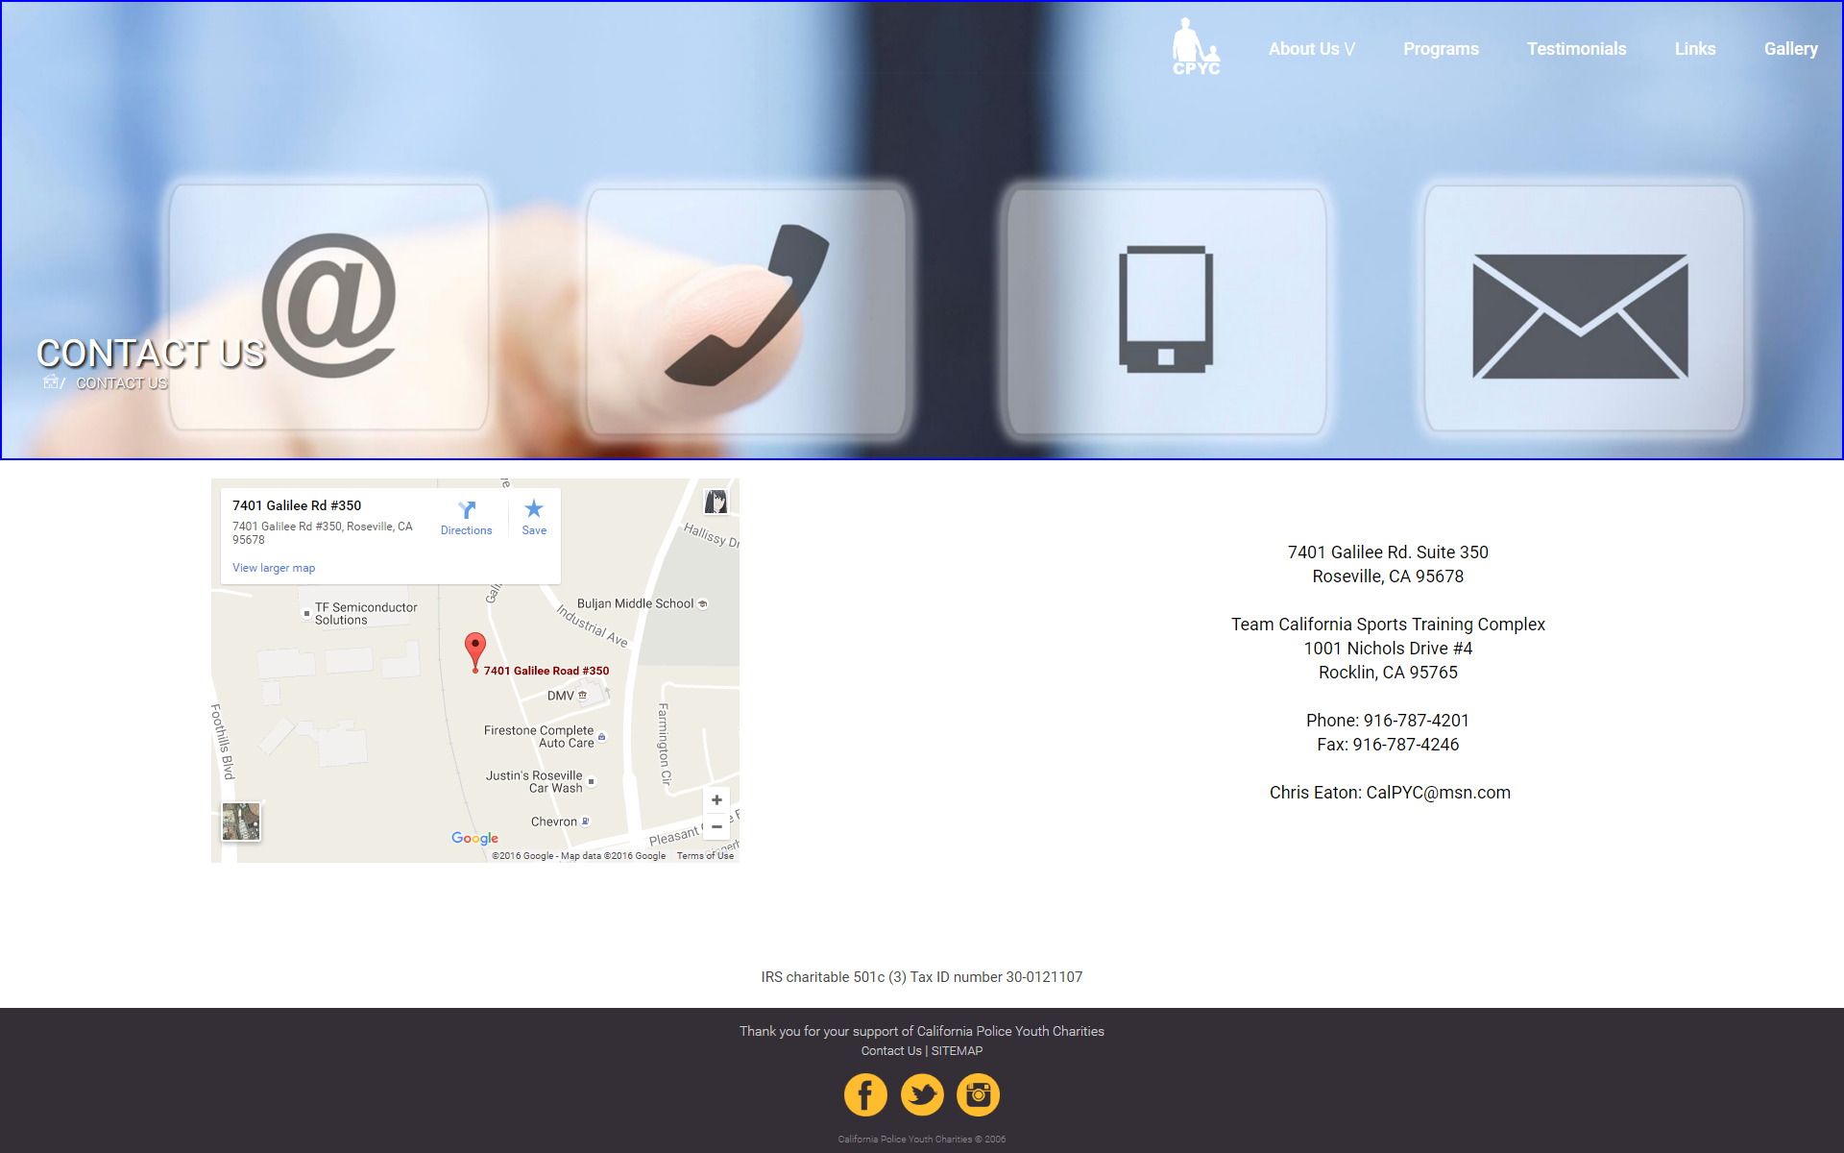

**Youth Programs**

On this page, you can edit the hero image and make changes to the list of youth programs that California Police Youth Charities support. You can do the latter by accessing the supportprograms.html file and editing the lines of text between each <br> tag nested in the overall <p> tag, which can be found in either the div with the ypfirstsec div or the div with the ypsecondsec id.

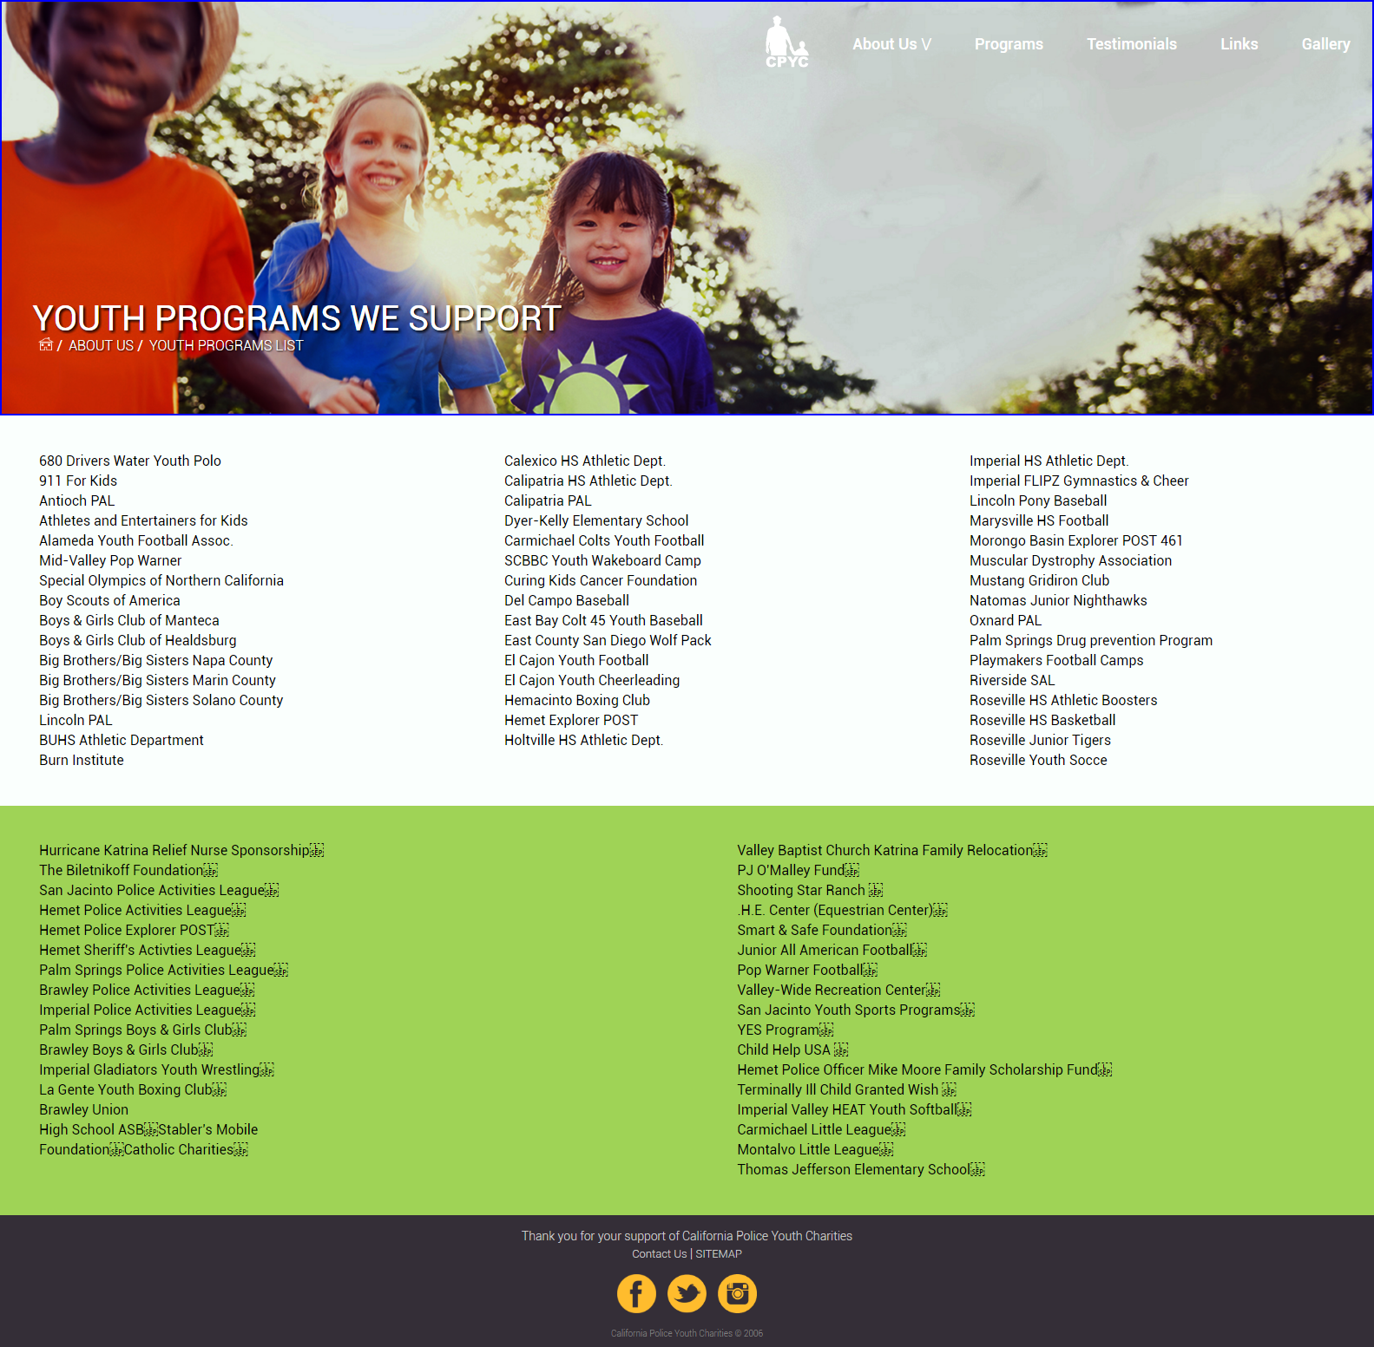

**Donations**

For the donations page, you can access the donate.html file in order to modify the form if necessary. You can add text options to the dropdown menus as well as add form elements to the form or remove form elements from the form, such as dropdown menus, radio boxes, and input fields. Also, the script pertaining to the donate button should not need to be edited since the form will already be submitted to the proper location.